OO Analysis and Design Lab Week 2

# Purpose of Lab : To understand event Analysis and System Sequence Diagrams

# Instructions:

Q1 Please refer to the Public University Registration System Problem Statement below and answer the given questions

### PUBLIC UNIVERSITY REGISTRATION SYSTEM CASE – ANALYSIS

The Schedule of classes for each term is produced in advance of the preregistration data according to a timetable prepared by the Records office. By a date contained in the timetable, each department in the University must submit a list of classes scheduled for the term in question. These lists are combined to form a printed class schedule. The schedule is distributed free to each department office and to each professor; students must buy theirs at the bookstore.

During the preregistration period, students request the classes they would like to take, using a touch tone telephone. Each class request contains the student’s identifier and the identifier of the class for which the student wishes to register. If that class is not available, the student may enrol in a different section of the same course or another class. After a student has registered for as many classes as possible (up to a maximum number of units permitted), a class list is printed for that student. It shows the classes in which the student has enrolled.

A class roster, containing a list of the student’s names and identifiers, is printed for the professor teaching each class. The list is ordered alphabetically by the student’s last name.

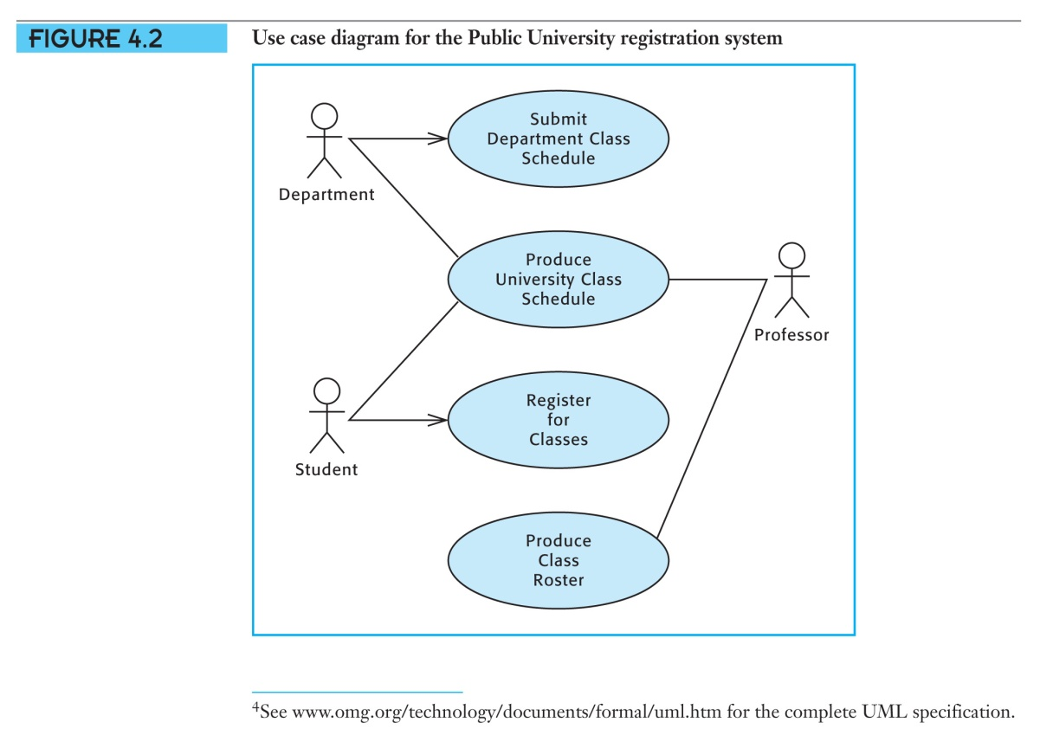

Additional cycles of system development often extend the scope of the system by identifying additional events to which users wish the system to respond. This exercise expands the scope of the student registration system.

The records office still maintains student’s grades and transcripts manually. The registrar wishes to extend the current automated system to be able to record student’s grades at the end of each term and produce grade reports for both students and instructors.

In your conversation with the Registrar, you have learned that within one week after the examination period instructors submit a grade sheet containing the grades students have earned in each class. The Records office keeps a permanent record of the grades and produces a student grade report , which is emailed to each student , and an instructor’s grade report, which is distributed to each faculty member.

1. *Identify the additional events to which the automated system must now respond.*
2. *Modify the event table below to incorporate these events. Imagine that each system input associated with an event arrives individually.*
3. *List other events which might be included in a University Registration system of extended scope.*
4. *Modify Use Case diagram to incorporate additional requirements*
5. Prepare a use case narrative for the additional events in the Public Registration system.

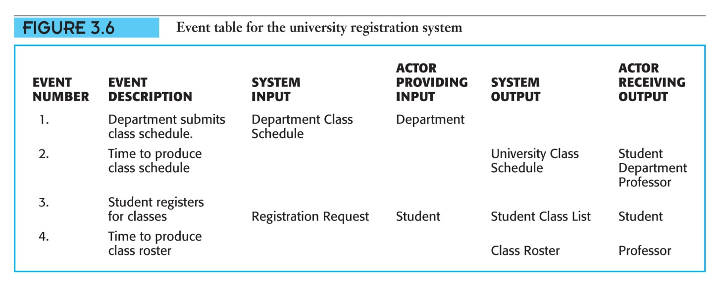

Q2 Modify the use case narrative for **Register for**

**Classes** to require that the system check prerequisites before adding a student to a class. Refer to figure below.

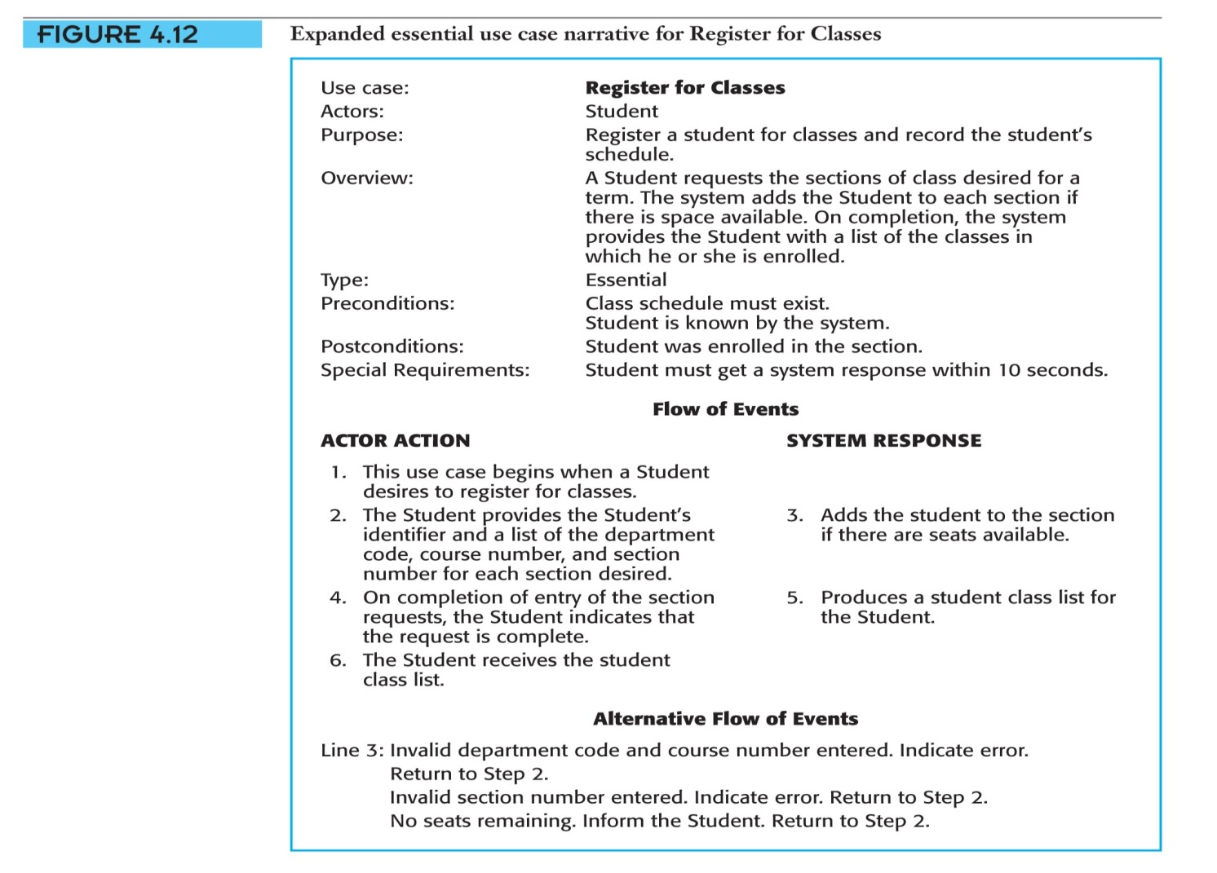

Q3 Draw a system sequence diagram for the typical flow of events for the use case **Submit Department Class schedule**.

To Create a system sequence Diagram in Visual Paradigm you draw a sequence diagram and only use one lifeline to represent system .

**Note:** Check this video out

<http://www.youtube.com/watch?v=Mqy569thFN8>

# Sequence Diagram Example

**Object Lifeline representing a system**

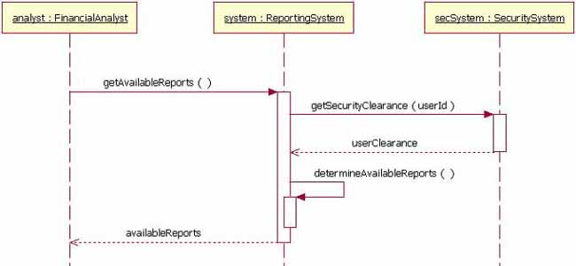

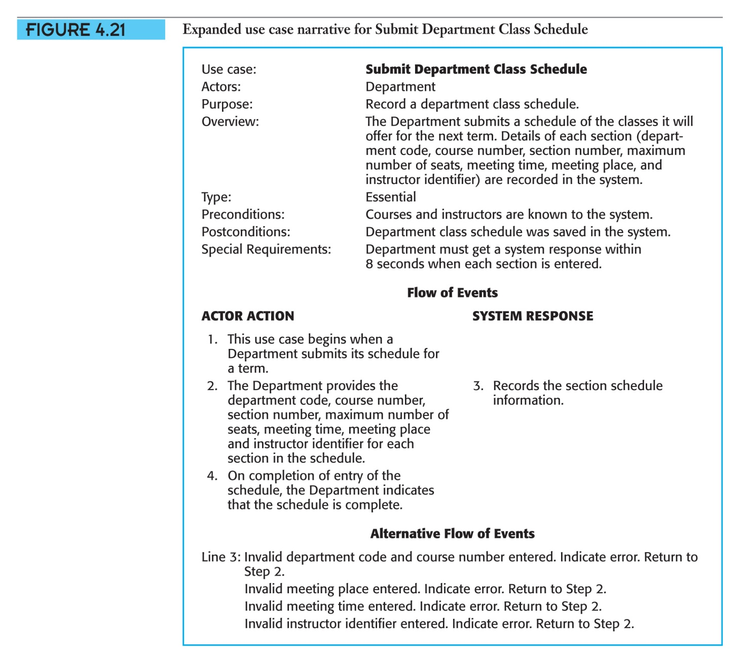

Q4 Draw a system sequence diagram for the use case **Check out library Book** shown in figures below.

